LAB ASSIGNMENT: IOT DEVICE MANAGEMENT API (PHP)
STEP 1: INSTALL & SETUP ENVIRONMENT
Before coding, ensure your local server is running.
Test first using phpinfo() function
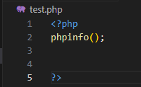
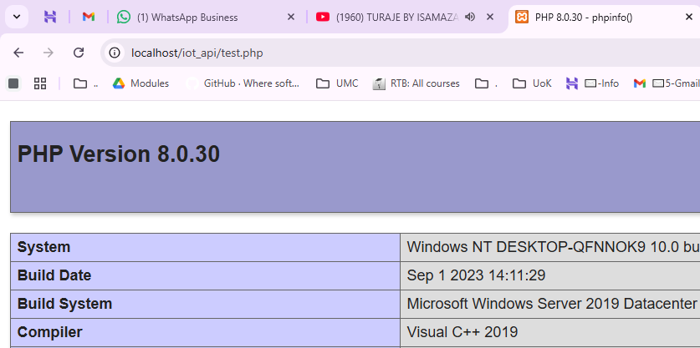

- Action: Start Apache and MySQL in your XAMPP control panel.
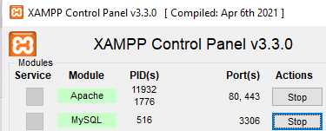
- Action: Open VS Code and create a new folder named iot_api
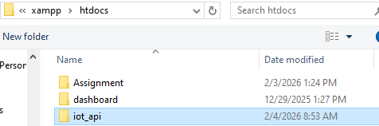

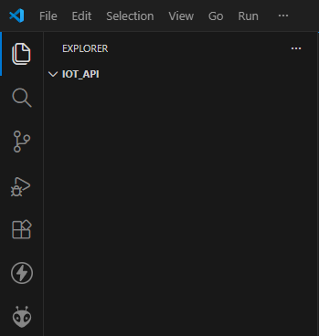The folder is opened in code

STEP 2: CREATE A DATABASE AND TABLE
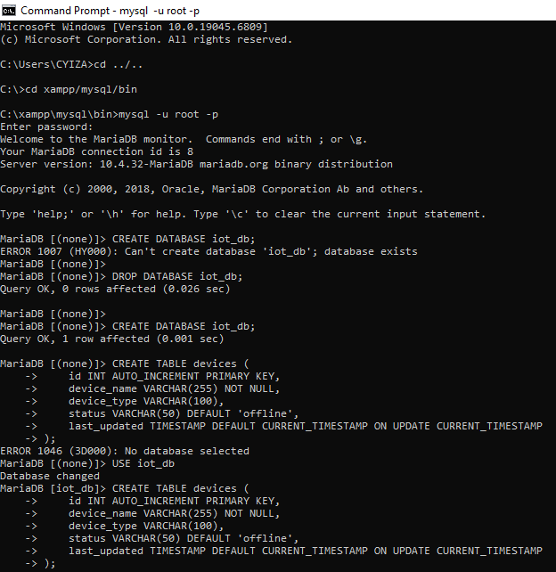

STEP 3: CONNECT TO THE DATABASE (DB.PHP)
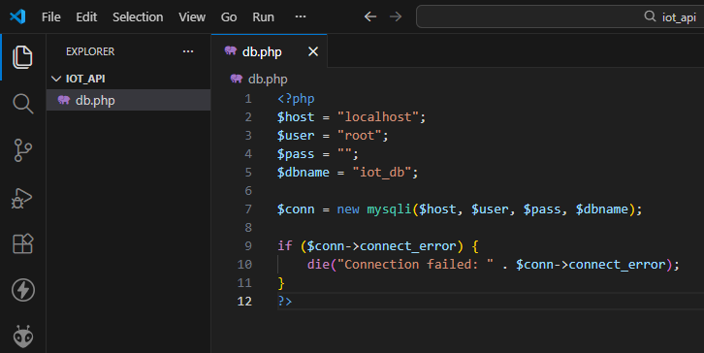
STEP 4 – (STEP 9:) CREATE AND EXECUTE THE INSERT QUERY (CREATE_DEVICE.PHP)
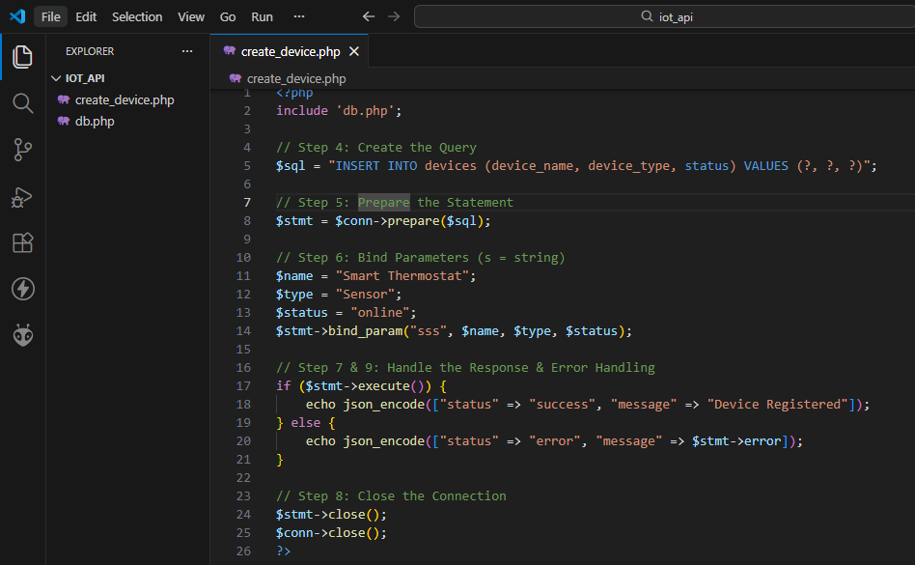

STEP 10: TESTING CREATE
You must see the "Influence" of your API.
- Action: Open your browser or Postman.
- URL: Navigate to http://localhost/iot_api/create_device.php
- Result: You should see a JSON success message.
http://localhost/iot_api/create_device.php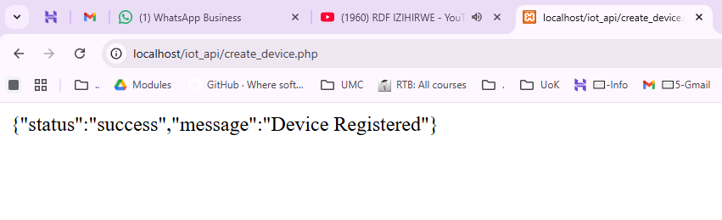

TO BE CONTINUED…

